
A 10
Sreenidhi Institute of Science & Technology
(An Autonomous Institution)
Code No: 103MB19

MASTER OF BUSINESS ADMINISTRATION

II - YEAR I - SEM, DECEMBER, 2011 (REGULAR)

PERSONALITY DEVELOPMENT & LOGICAL RESONING

Time: 3 Hours Max. Marks : 60

Note : No additional answer sheets will be provided.

------------------------------------------------------------------------------------------------------------------------------

ANSWER ANY FIVE QUESTIONS

1. Personality is the brand image of an individual. Substantiate.
2. Explain the 7Cs and 3Vs of effective communication.
3. Draw the relation between Emotional Intelligence and Team-Spirit.
4. What are the various job search techniques? Write a note on each.
5. (i) (a) 4,8,28,80,244_______________
(b) BZA, DYC, FXE,____________ JVL.
(ii) (a) Vigilant: Alert: Viable: _____________________
(b) Find odd one in customs, service tax, income tax, Sale.
(iii) D, the son -in-law of B, is the brother-in law of A what is the brother of C. How is A related to B.
(iv) A, P, R, X, Sand Z are sitting in a row Sand Z are in the centre, and A and P are at the ends. R is sitting on the left of A. then who is sitting on the right of P?
(v) Today is Friday. After 62 days it will be
(vi) In a certain code language, CREATIVE is written as BDSBF. How is TRIANGLE
written in that code?
6. (a) The Director of a business school wishes to select four members of a faculty
student committee as representatives to meet with the school's board of directors. The faculty student committee consists of exactly four faculty members K.L.M and N and four students P.Q.R and S. The director can select any of the committee member as representatives as long as he observe the following restrictive the group of four
representatives must consist of exactly two faculty members and two students.
(b) Either K (or) L must be one of the representatives, but K and L cannot both be
representatives
(c) lf P is a representative, M must also be a representative
(d) If R is a representative, L cannot be a representatives.
(i) If L, Nand Q are representatives which one also be a representative?
(ii) If neither Q nor S is a representative, which one also be a representative?
(iii) If neither Q nor S is a representative, which pair of faculty members must be representatives?
(iv) If L is a representative, the other three are?
7. The total marks obtained by the students in the examination are 450. Answer the
following questions based upon the information provided in the pie-chart.
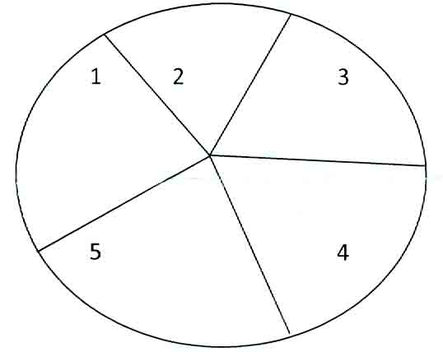
1. Chemistry - ( 55° ) 2. Mathematics( 80°) 3. English ( 65° )
4. Comp science ( 70° ) 5. Physics ( 90° )
(i) What percent of the total marks were obtained by the students in physics?
(ii) The aggregate marks obtained by the students averaged over the five subjects is
(iii) The students scored 100 marks in which subject?
(iv) The subject in which the students chemistry, Maths and English together are
what percent of the total marks?
(v) The marks obtained in three subjects Chemistry, Maths, English together are
what percent of the total marks?
(vi) The marks scored by the students in computer science and physics exceed the
marks scored in chemistry and English by?
-- 00 -- 00 --

